**HADOOP COMMANDS**

1. Create a folder in HDFS by name “dir01” and move input1.txt , input2.txt and input3.txt into /dir01.

**Ans:**

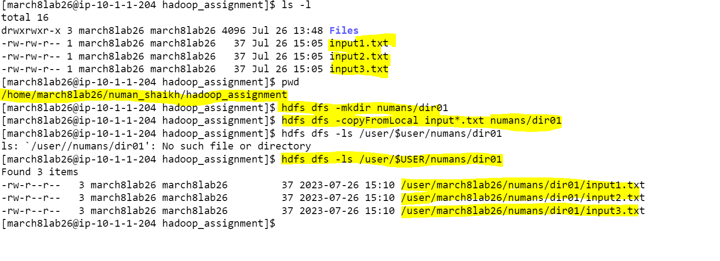

1. List only the file names present in “/dir01”

**Ans:**

1. Change the replication factor for the content present in directory “/dir01” to 5 and display the replication factor for the files present in “/dir01”

**Ans:**

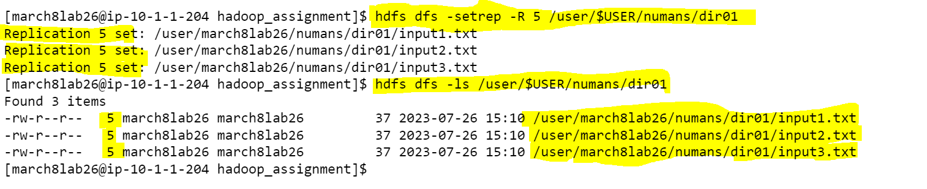

1. Create a folder in HDFS by name “scenario01” and create directory “level01” inside “scenario01” directory and create another directory “level02” inside directory “level01”. Once the required directories are created copy input1.txt to scenario01, input2.txt to level01 and input3.txt to level02 and finally recursively print only the file names present in directory scenario01

**Ans:**

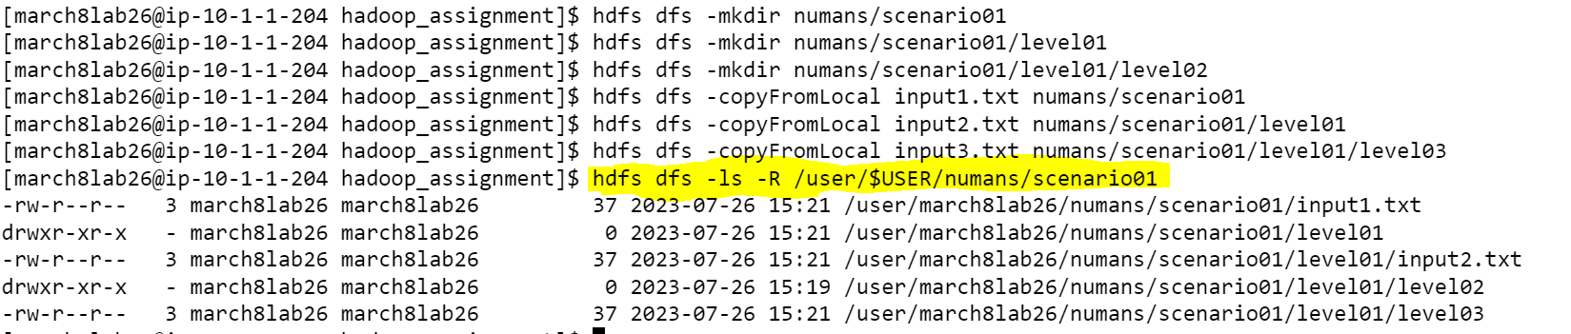

**YARN COMMANDS**

1. Run word count and get the app ID

**Ans:**



Application Id

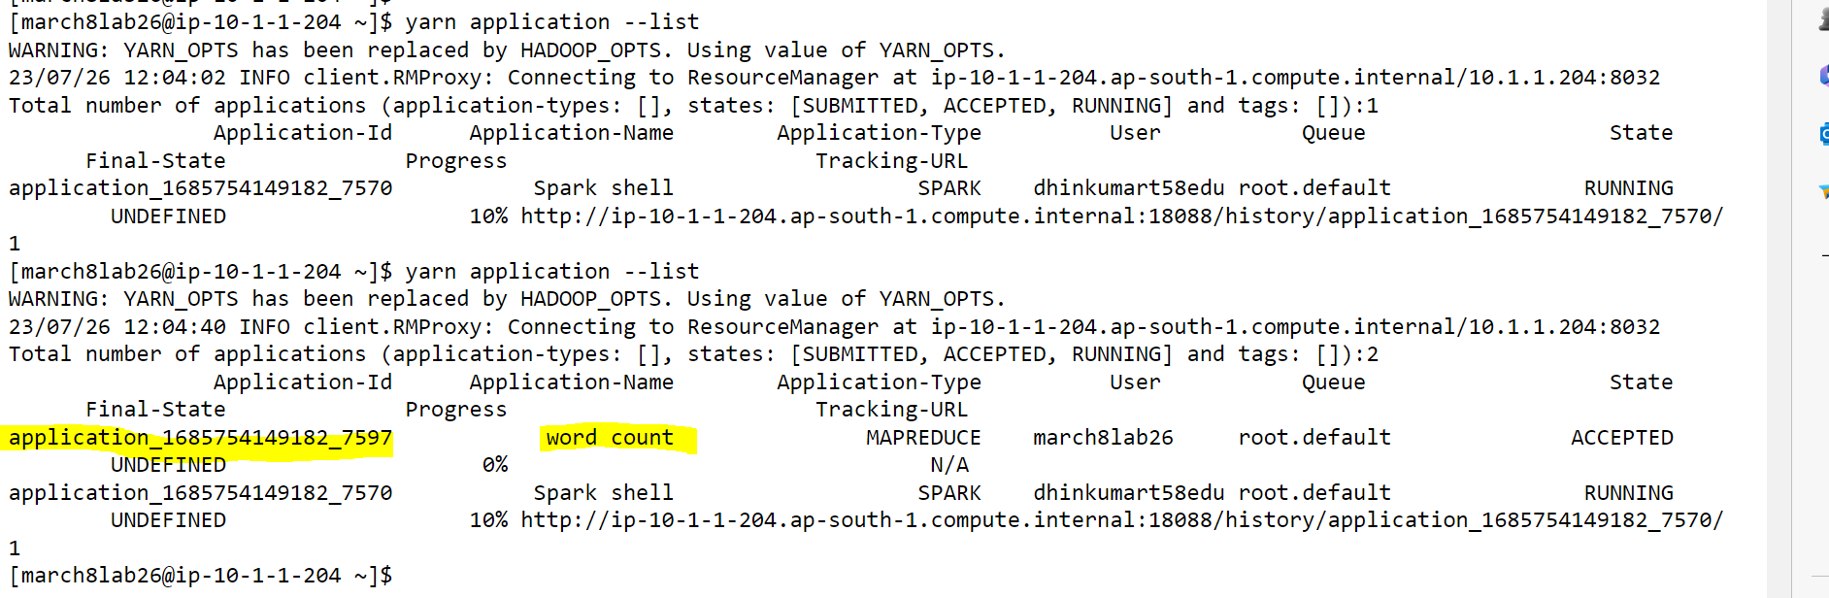

1. Rerun wordcount and kill the application.

**Ans:**

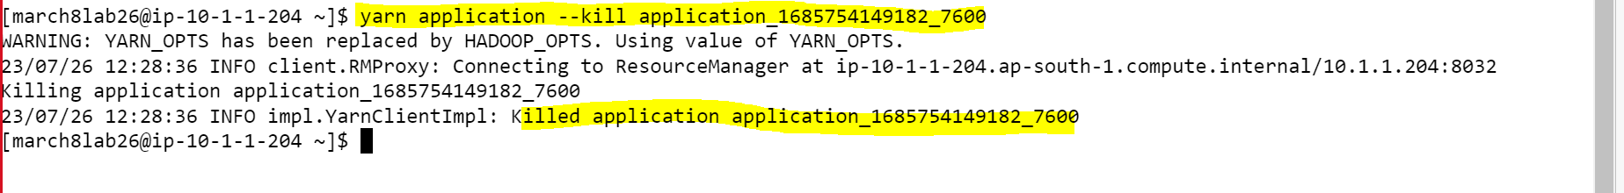

1. Job which are in running state

**Ans:**

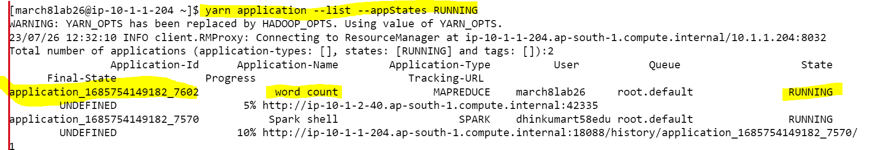

1. View the logs of any of the jobs which are already completed.

**Ans:**

**yarn logs --applicationId application_1685754149182_7629**

